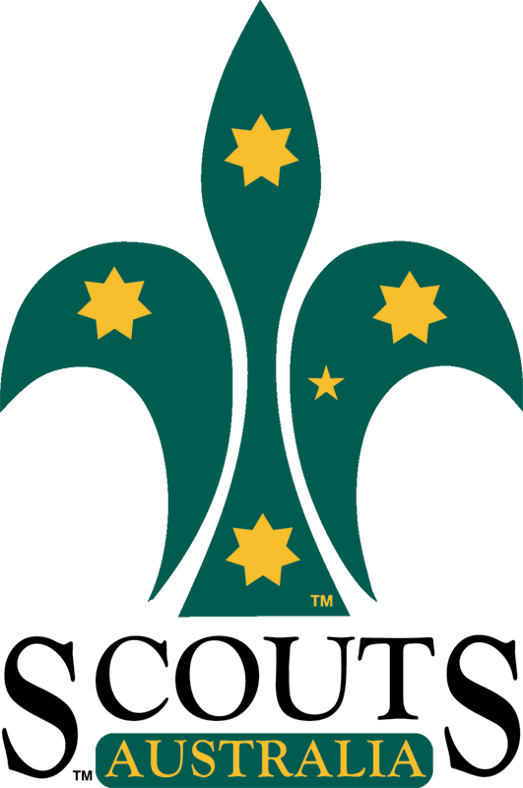
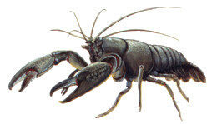
Rosanna Cubs/Scouts

Yabby / BBQ Night

Next Tuesday (the 15th) we’ll be having a BBQ and Yabbying night at Binnak Park in Nth Watsonia.
Scouts will also be on Wednesday the 16th, so the Yabby night is ‘optional’…. if coming please notify Wayne, as per “catering” below.

Location: Binnak Park (Melway 10 D11). Closest street is Binnak Dr, between Glendalough Ct and Dunraven Ct. On some Melways, the area we’re meeting is just marked as “Play”, but there is a BBQ area and small lakes there.
Time: Tuesday 15th February, 6:30pm start and pickup at 8:30pm.
Food: Meat, bread, drinks etc., will be supplied for the Cubs and Scouts.
Parents/Siblings: Parents/siblings are welcome, but please bring your own food to cook/eat and parents please supervise your other children.
For Yabbying: Please bring an old stocking and coat hanger if you wish (to make a ‘net’) and, if you intend on being successful, a bucket (or ice-cream container and lid) to take your yabby(s) home. Yabby meat and string will be supplied.
Bring: Cubs and Scouts to wear hat and uniform – wear sunscreen.

Catering: Please contact Wayne (Akela) at akela@rosannacubs.org or 0411 121 495 before
this weekend with Cub/Scout numbers attending and any special food requirements.

Regards

Akela (Wayne) Michelle
akela@rosannacubs.org michelle@rosannascouts.org
0411 121 495 0429 377 660

See us at www.rosannacubs.org www.scouts.rosannascouts.org

